交通数据分析与应用 R assignment1

学号：2331630

姓名：冯蕊

2023-11-13

# Task1

## Load your own .csv file into R, report the dimension of your data frame.

driving <- read.csv("C:\\Users\\23367\\Desktop\\R assignment1\\driving.csv")  
driving |> dim()

## [1] 220 22

## Generate a scatter plot using the plot() function.

plot(x=driving[,1], y=driving[,2],   
 col=adjustcolor("darkred", 1/2),  
 xlab="time", ylab="Speed/X",  
 main = "Speed-time Scatter Plot")

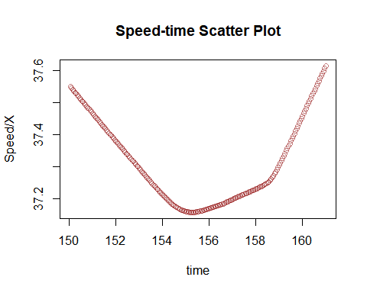

# Task2

## Write a loop to calculate the mean value of a random numeric vector of length 50.

# Generate a random numeric vector  
vec <- rnorm(50)  
  
# Calculate the sum  
sum_vec <- 0  
for (i in 1:length(vec)){  
 sum_vec = sum_vec + vec[i]  
}  
  
# Calculate the mean value  
mean_v <- sum_vec/length(vec)  
mean_v

## [1] -0.0317242

## Verify that it is correct.

mean(vec)

## [1] -0.0317242